**Coordinated Set Identification Service**

The Coordinated Set Identification Service (CSIS) can be used by devices to be discovered as part of a Coordinated Set, like TWS

A Coordinated Set is defined as a group of devices that are configured to support a specific scenario.

CSIS对设备的实际特性和功能是不可知的。CSIS的目的是指定如何将设备作为协调集的一部分发现，以及如何授予客户端对协调集的独占访问权限，以避免多个客户端同时访问协调集时出现竞争条件

To be discovered as part of a Coordinated Set, devices must share a Set Identity Resolving Key (SIRK), which is used to generate and resolve a random Resolvable Set Identifier(RSI) that can be advertised.

SIRK can be set during the manufacturing of the device, or another method could be used.

An RSI is a random set identifier that reduces the ability to track a device over a period by changing on a frequent basis.

To discover a Coordinated Set and its members, a device discovers at least one member of the Coordinated Set (e.g., via friendly name), connects to it, and obtains the SIRK. The SIRK can be exposed in encrypted form or in plain text form. The discovering device uses the SIRK to resolve RSIs from other advertising devices and to determine that the advertising devices belong to the Coordinated Set identified by that SIRK when the RSI is successfully resolved.

The SIRK of the Coordinated Set may also be obtained by using an OOB procedure.

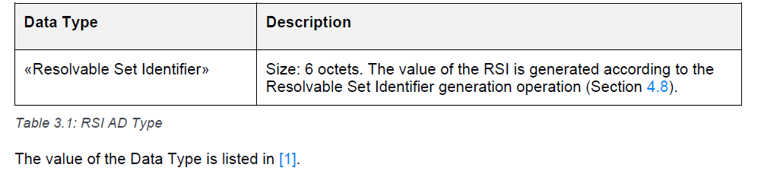

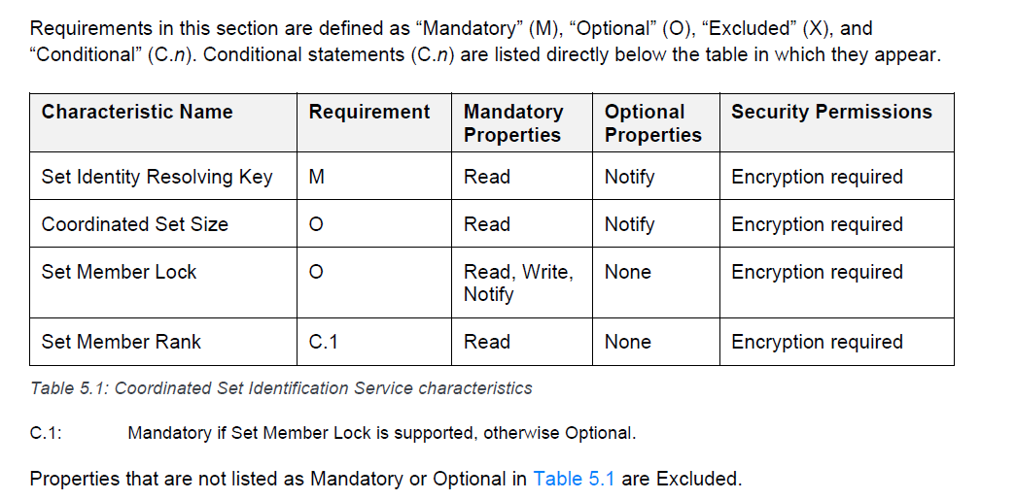

## SIRK:

The SIRK shall be a 128-bit long random number.

A server shall expose the SIRK in encrypted form or in plain text or by using an OOB procedure

A Coordinated Set is uniquely identified by the SIRK

When using an OOB procedure, the SIRK may be sent in plain text or in encrypted form unless otherwise specified by a higher-layer specification

Type:

0x00 表示加密，0x01 表示明文

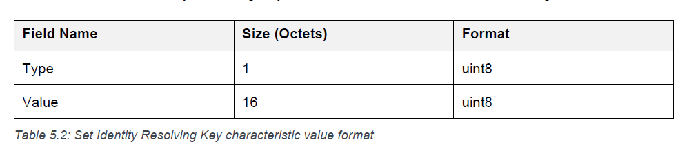

If a server exposes a SIRK in encrypted form, the server shall not expose the same SIRK in plain text form.

A server that only exposes a SIRK via an OOB procedure shall reject the request to read the SIRK by replying to the request PDU with an Error Response with the error code OOB SIRK Only

If a server is provisioned with a new SIRK when connected, and the value of the Client Characteristic Configuration descriptor is configured for notifications, then the server shall notify the new characteristic value to the client

If a server is provisioned with a new SIRK when not connected, and the value of the Client Characteristic Configuration descriptor is configured for notifications, then the server shall notify the characteristic value when reconnecting to a bonded client.

Coordinated Set Size

exposes the number of devices comprising the Coordinated Set

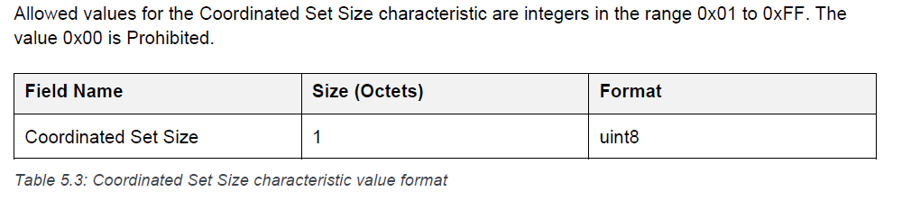

## Set Member Lock

allows clients to have exclusive access to the server to minimize race conditions that might occur when multiple clients are accessing multiple servers of the same Coordinated Set at the same time.

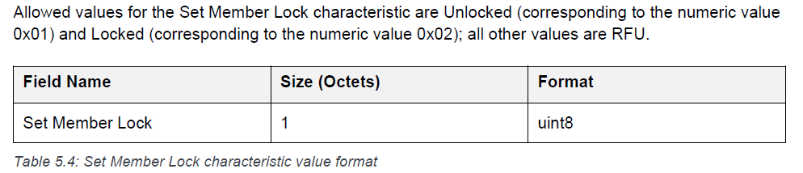

If a client attempts to write an RFU value to the Set Member Lock characteristic, the server shall reply with an Error Response with the Error Code Invalid Lock Value

A server shall expose the same value of the Set Member Lock characteristic to all clients.

If the server and client are bonded, then the value of the Set Member Lock characteristic shall be persistent across connections within the TCSIS(lock_timeout)

If a client requests to write Locked to the Set Member Lock characteristic, and the value of the Set Member Lock characteristic is equal to Unlocked, then the server shall write the requested value, shall reply with the Write Response (i.e., the server grants the lock to the client), and shall set a timer to TCSIS(lock_timeout)

If the timer TCSIS(lock_timeout) expires, then the server shall set the value of the Set Member Lock characteristic to Unlocked.定的时间既要能让所有的server 都被set 这个值，又不能太长导致别的client 空等

When the server and the client are not bonded and they disconnect when the value of the Set Member Lock characteristic is set to Locked, the server shall set the value of the Set Member Lock characteristic to Unlocked immediately after the disconnection.

解锁的时候是自己解自己的锁，不能解别的client 挂的锁，不然server报错

## Set Member Rank

exposes a numeric value that shall be unique within a Coordinated Set and that allows a client to perform procedures with servers that are part of a Coordinated Set in a defined order， 给set 里面的设备排号，方便单独操作

